

**Western Australian Certificate of Education**

**ATAR course examination, 2017**

**Question/Answer Booklet**

11 PHYSICS

Name

**Evaluation 1 - Airbags**

|  |  |  |  |  |  |  |  |  |  |  |
| --- | --- | --- | --- | --- | --- | --- | --- | --- | --- | --- |
| Student Number: In figures |  |  |  |  |  |  |  |  |  |  |

**Mark: ** In words

#### Time allowed for this paper

Reading time before commencing work: nil

Working time for paper: fifty minutes

**Materials required/recommended for this paper**

To be provided by the supervisor

This Question/Answer Booklet

Formulae and Data Booklet

***To be provided by the candidate***

Standard items: pens, (blue/black preferred), pencils (including coloured), sharpener, correction fluid/tape, eraser, ruler, highlighters

Special items: non-programmable calculators satisfying the conditions set by the School Curriculum and Standards Authority for this course

one A4 page of notes - handwritten

**Important note to candidates**

No other items may be taken into the examination room. It is your responsibility to ensure that you do not have any unauthorised notes or other items of a non-personal nature in the examination room. If you have any unauthorised material with you, hand it to the supervisor before reading any further.

**Structure of this paper**

|  |  |  |  |  |  |
| --- | --- | --- | --- | --- | --- |
| **Section** | **Number of questions available** | **Number of questions to be answered** | **Suggested working time**  **(minutes)** | **Marks available** | **Percentage of exam** |
| **Section One:**  **Short Answers** | - | - | - | - | - |
| **Section Two:**  **Problem-solving** | - | - | - | - | - |
| **Section Three:**  **Comprehension** | 6 | 6 | 50 | 18 | 100 |
|  |  |  |  | **Total** | 100 |

**Instructions to candidates**

1. The rules for the conduct of examinations at Holy Cross College are detailed in the College Examination Policy*.* Sitting this examination implies that you agree to abide by these rules.

2. Write your answers in this Question/Answer Booklet.

3. Working or reasoning should be clearly shown when calculating or estimating answers.

4. You must be careful to confine your responses to the specific questions asked and to follow any instructions that are specific to a particular question.

5. Spare pages are included at the end of this booklet. They can be used for planning your

responses and/or as additional space if required to continue an answer.

• Planning: If you use the spare pages for planning, indicate this clearly at the top of the page.

• Continuing an answer: If you need to use the space to continue an answer, indicate in the original answer space where the answer is continued, i.e. give the page number. Fill in the number of the question(s) that you are continuing to answer at the top of the page.

6. Answers to questions involving calculations should be ***evaluated and given in decimal***

***form*.** It is suggested that you quote all answers to ***three significant figures***, with the

exception of questions for which estimates are required. Despite an incorrect final result, credit may be obtained for method and working, providing these are ***clearly and legibly set out***.

7. Questions containing the instruction "estimate" may give insufficient numerical data for their solution. Students should provide appropriate figures to enable an approximate solution to be obtained. Give final answers to a maximum of two significant figures and include appropriate units where applicable.

8. Note that when an answer is a vector quantity, it must be given with magnitude and direction.

9. In all calculations, units must be consistent throughout your working.

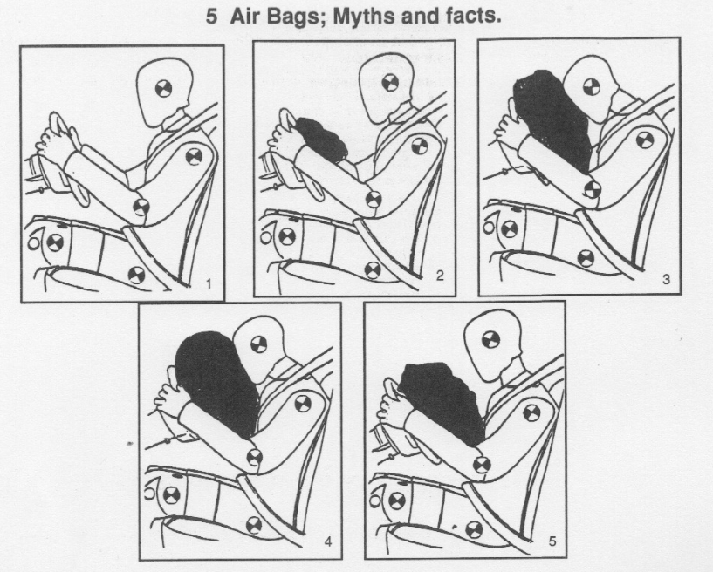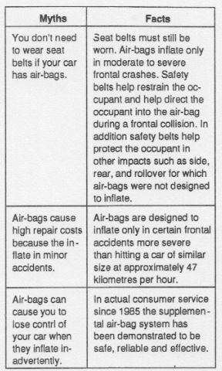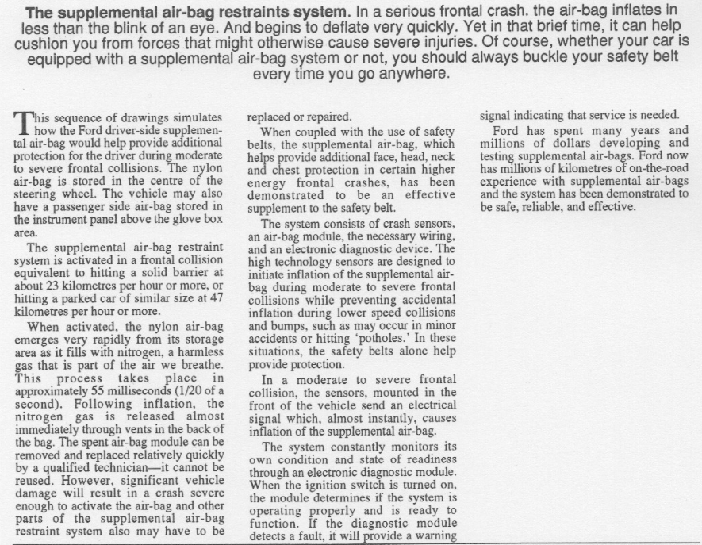

The first inflatable device for crash landings was created for an aeroplane during the Second World War. Airbags began to appear in cars in the 1980s.

1. Airbags work by increasing the time it takes to absorb the shock of an impact. Use Physics principles to explain why this is beneficial for the occupant of a car in a collision.

(4 marks)

2. How does the air bag assist in minimising injury to the driver? (3 marks)

3. Why is the airbag stored in the centre of the steering wheel? (2 marks)

4. With airbags now standard in motor vehicles, do you still need to wear a seat belt? In your answer, disregard the road rules in place. Explain using Physics principles whether it is necessary.

(3 marks)

5. Air bags require sensors to deploy them. Where are these sensors located, and what do they measure? (2 marks)

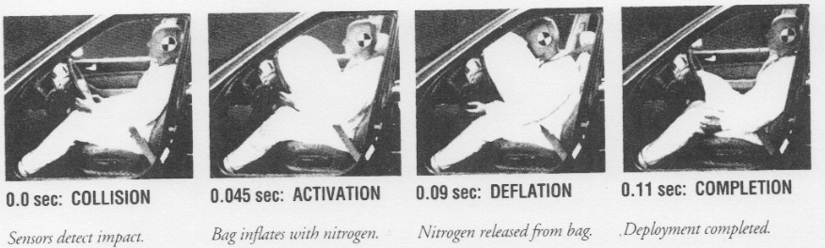

6. In these photographs provided by the Honda Motor Company, it appears that the air bag is deflated just about the same time that the driver’s head comes in contact with the bag. Why is this an important safety design? (3 marks)